**GANPAT UNIVERSITY**

**INSTITUTE OF COMPUTER TECHNOLOGY**

A Report on **"LOGOUT-WORLD'S BIGGEST CYBER AWARENESS CAMPAIGN"-BY MOZILLA CAMPUS CLUB** held during Jan 21st , 2018.

As per the culture of Ganpat University, every academic year Institute of Computer Technology organizes technical event for aspirants assembling from various engineering colleges with a very high competitive spirit to participant and with the strong determination to include their achievements & accomplishments to their resumes.

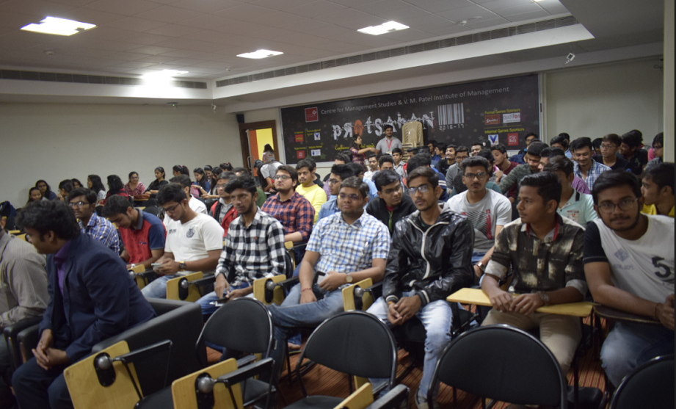

For the preceding academic Year 2018 we have organized Mozilla Campus Club event with the same enthusiasm and determination among the new set of student volunteers and faculty coordinator during Jan 21st,2018. The event was successful enough to attract as many as 200 registrations for the event.

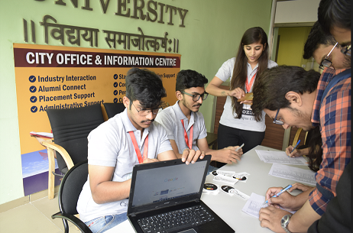

The event organized about Privacy and Security  awareness :  "Logout"   by Mozilla Campus Club  handled by **Dhruv Pandit** Representative of Mozilla Campus Club . The event was part of  Inaugural ceremony for Mozilla Campus Club at Ict. The event was started by Lighting the Lamp of Knowledge and Wisdom by our Honourable Principal of ICT Dr. Hemal Shah, Excecutive Dean Satyen Parikh, Keynote Speaker of the Event Mr.Viral Parmar and Faculty Incharge for the event Prof. Nidhi Thacker. After Lighting up the event the Momento was given to our Keynote Speaker by our Principal and Executive Dean too.

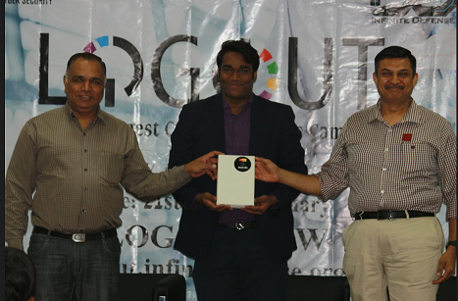

Dhruv Pandit Had given a brief introduction about what is Mozilla Club and what does it do ?Then, our Keynote Speaker **"Viral Parmar -Cyber Security Expert".**He had given session about security and covered topics like how hackers do hacking, how the steal information,Right to Privacy,Theft Identity etc. were covered.The participants were having a wonderful interaction with the speaker too.

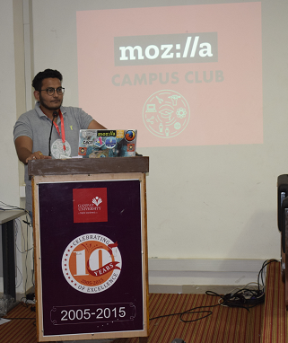 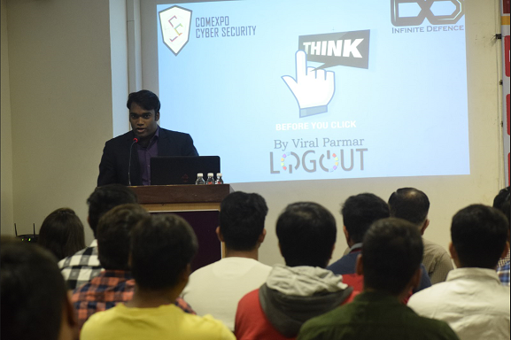

After the ending of session we given a feedfack forms for knowing the feed back from the participants and the participants had also got the **E-Certificate** And stickers of Mozilla Campus Club too. And we also had a photo session in which we had a group selfie with all the participants and the participants also had a photos with photo frame of mozilla campus club and Firefox Quantum made by our mozilla team Members. Department feels proud to organize such a successful event and would like to convey thanks to principal and management for their timely advice and cooperation for organizing successful Event.

Especially thanks to Volunteers Of Mozilla Campus Who make this event Successful by giving their lots of efforts. 